Unilateral Retinitis Pigmentosa: Case Report.

Retinose Pigmentar Unilateral: Relato de Caso.

Autores
Ricardo Evangelista Marrocos de Aragão. Doutor em Medicina pela Universidade de Regensburg/Alemanha. Preceptor de Retina do Hospital Universitario Walter Cantitio/UFC. Tel 991379313. ricardomarrocos@yahoo.com
Ieda Maria Alexandre Barreira. Especialista em retina pela UNIFESP. iedabarreira@yahoo.com.br
Ariane Sa Vieira Bastos. Fellow em Plastica Ocular do Serviço de Oftalmologia do Hospital Universitário Walter Cantídio/UFC. arianesvv@yahoo.com.br
Gustavo Jose Arruda Mendes Carneiro. Residente do segundo ano do servico de oftlmologia do Hospital Universitario Walter Cantidio/UFC. gustavo.amc@gmail.com
Talles Peterson Cavalcante Oria. Residente do segundo ano do Serviço de Oftalmologia do Hospital Universitário Walter Cantídio/UFC. tallespeterson@hotmail.com
Trabalho realizado na No Hospital Universitario Walter Cantidio da Universidade Federal do Ceará.
Endereço do Autor Correspondente:
Ricardo Evangelista Marrocos de Aragão
Rua Osvaldo Cruz, 2335 Bairro Dionísio Torres
Fortaleza-CE CEP 60125-151 Tel. 85 32617528
E-mail: ricardomarrocos@yahoo.com
Retinose pigmentar unilateral e uma rara distrofia retiniana. Afeta somente um olho, com o olho contralateral totalmente sem alteracoes. Outras etiologias devem descartadas para o diagnostico. Relatamos o caso de uma paciente.
Abstract
Unilateral retinitis pigmentosa (URP) is a rare tapetoretinal dystrophy affecting only one eye. Criteria are necessary to make a correct diagnosis of URP: exclude all infective etiologies, check that the clinical signs of retinitis are present in the affected eye and the total absence of any signs or symptoms of retinitis pigmentosa in the fellow eye. Electroretinogram (ERG) and electro-oculogram (EOG) are useful for the correct diagnosis. In this paper we report one case.
Keywords: Retina; Photoreceptor Cells, Vertebrate; Retinitis Pigmentosa; Vision, Ocular; Mutation.

Resumo
Retinose pigmentar unilateral e uma distrofia tapetoretiniana rara afetando somente um olho. Critérios devem ser impregados para um diagnostico correto: exclusão de todas etiologias infecciosas que cursam com quadro semelhante, presença dos sinais clínicos de retinose pigmentar no olho afetado e ausência de qualquer sinal no olho contralateral. Eletroretinograma (ERG) e eletro-oculograma(EOG) são bastante úteis no diagnostico. Neste artigo relatamos o caso de uma paciente.
Descritores: Retinite Pigmentosa; Células Fotoreceptoras de vertebrados; Mutação; Retina; Visão ocular.

Introducion

Retinitis Pigmentosa (RP) is a group of inherited disorders of the retina which are characterized by progressive demage involving photoreceptors and often, subsequently other cell layers, associated with progressive cell loss and eventual athophy of several retina layers. The consequent visual impairment is usually manifested as night blindness, visual field loss and, in some cases, central visual disorders. (1) RP is a hereditary disorder that can be autossomal dominant, autossomal recessive or X-linked.(2) The classically described fundus appearence of RP includes attenuated retinal vessels, mottling and granularity of the retinal pigment epithelium (RPE), bone-spicule intraretinal pigementation and optic nerve head pallor. (3) Presentation is bilateral and symmetrical. Unilateral retinitis pigmentosa (URP) is a rare condition. The vast majority of the published cases, were reported before the advent of electroretinography and electrooculography. The diagnosis was based on symptoms and fundus features only, and in that way may have resulted from other acquired diseases. Ocular eye trauma, syphilis or other ocular inflammation can mimic URP.
Despite patients with URP have been described, none of these cases have been reported to be familial or associated with gene mutation and the cause of these cases remains unclear. (4) A close relationship between URP and bilateral retinitis pigmentosa has been described, but the genetic mechanisms to explain this remain to be identified.

Case Report

A 60 year-old female was refered to us with headache complains. She had controlled hypertension. Her family history was normal.
On examination, best-corrected visual acuity (BCVA) was 20/80 in the right eye (RE) and 20/40 in the LE. The slitlamp examination had shown in OU subcapsular cataract, more in the RE. Intraocular pressure was normal in both eyes. The fundus appearence was characterized by typical bone spicule formation in the midperipheral retina, associated with waxy color of the optic disk, narrowed retinal vessels and tobacco dust in the vitreous in the RE. The LE was normal (Fig 1 and 2). Computadorized visual field examination in the RE was tubular , with subnormal foveal value, while in the LE it was normal (Fig 3). The flash ERG, performed according to the ISCEV standarts, was markedly low in both photopic and scotopic components, while in the left eye it was normal (Fig 4). The standard EOG was subnormal in the RE and normal in the LE. ( Fig 5).

Discussion

URP is a rare degeneration of photoreceptors involving retinitis pigmentosa-like changes in one eye with the other eye completely unaffected. The criteria for diagnosis of URP are: 1. The presence in the affected eye of functional changes and an ophthalmoscopic appearance typical of retinitis pigmentosa. 2. The absence in the other eye of symptoms of a RP with the presence of a normal electroretinogram ( ERG). 3. A sufficiently long period of obsevation. ( over 5 years) to rule out a delayed onset and the unaffected eye. 4. Exclusion of an inflammatory or trauma cause in the affected eye. (2) RP frequently has a hereditary predisposition. URP instead, appears more frequently in adult age, and sporadically.(1) Many other inherited retinal conditions may be confused with RP. Theses can be conditions confined to the retina or have associated systemic manifestations that may or may not be apparent at the time of examination. A number of acquired conditions can cause extensive chorioretinal atrofy that is difficult to distinguish from advanced RP. In such situations, specific details of the history or asimmetry of disease may be the most important differentiating factors. Diffential diagnosis of pseudoretinitis pigmentosas include retinal inflammatory diseases like, rubella retinopathy, syphilis, infections retinitis; autoimmune paraneoplastic retinopathy: drug toxicity.Traumatic retinopathy is probably the commonest acquired (5,6)
retinopathy that is confused with RP and may, with diffused unilateral subacute neuroretinitis ( DUSN), account for many previosly misnamed case of URP(2)
URP without pigmentary changes has been reported as well. It has been associated with heterochromia iridis, temporal arteritis, pit of optic disc, exfoliation syndrome, and glaucoma. Whether it is related with URP or they were just incidental findings is not clear, since only one case of each has been reported.

References
- Spadea, L, Magni, R, Ribaldi, G, Dragani, T, Bianco, G. Unilateral Retinitis pigmentosa: Clinical and Electrophysiological Report of Four Cases. Ophthalmologica 1998; 212(5):350-4.
- Thakur, A, Puri, L. Unilateral retinitis pigmentosa. Clin Exp Optom 2010; 93: 2: 102-4.
- Ryan, SJ, Hinton, DR, Schachat, AP, Wilkinson, P. Retina : Philadelphia: Elsevier Mosby; 2006.
- Mukhopadhyay, R, Holder, GE, Moore, AT, Webster, AR. Unilateral Retinitis Pigmentosa Occurring in an Individual With a Germline Mutation in the RP1 Gene. Arc Ophthalmol 2011; 129 (7): 954-6
- Traversi, C, Tosi, GM, Caparossi, A. Unilateral retinitis pigmentosa in a woman and pigmented paravenous chorioretinal atrophy in her daughter and son. Eye (London) 2000; 14: 395-7.
- Farrell, DF. Unilateral retinitis pigmentosa and cone-rod dystrophy. Clin Ophthalmol; 2009: 3: 263-270.

Figure 1. Flourescein angiography of the right eye.
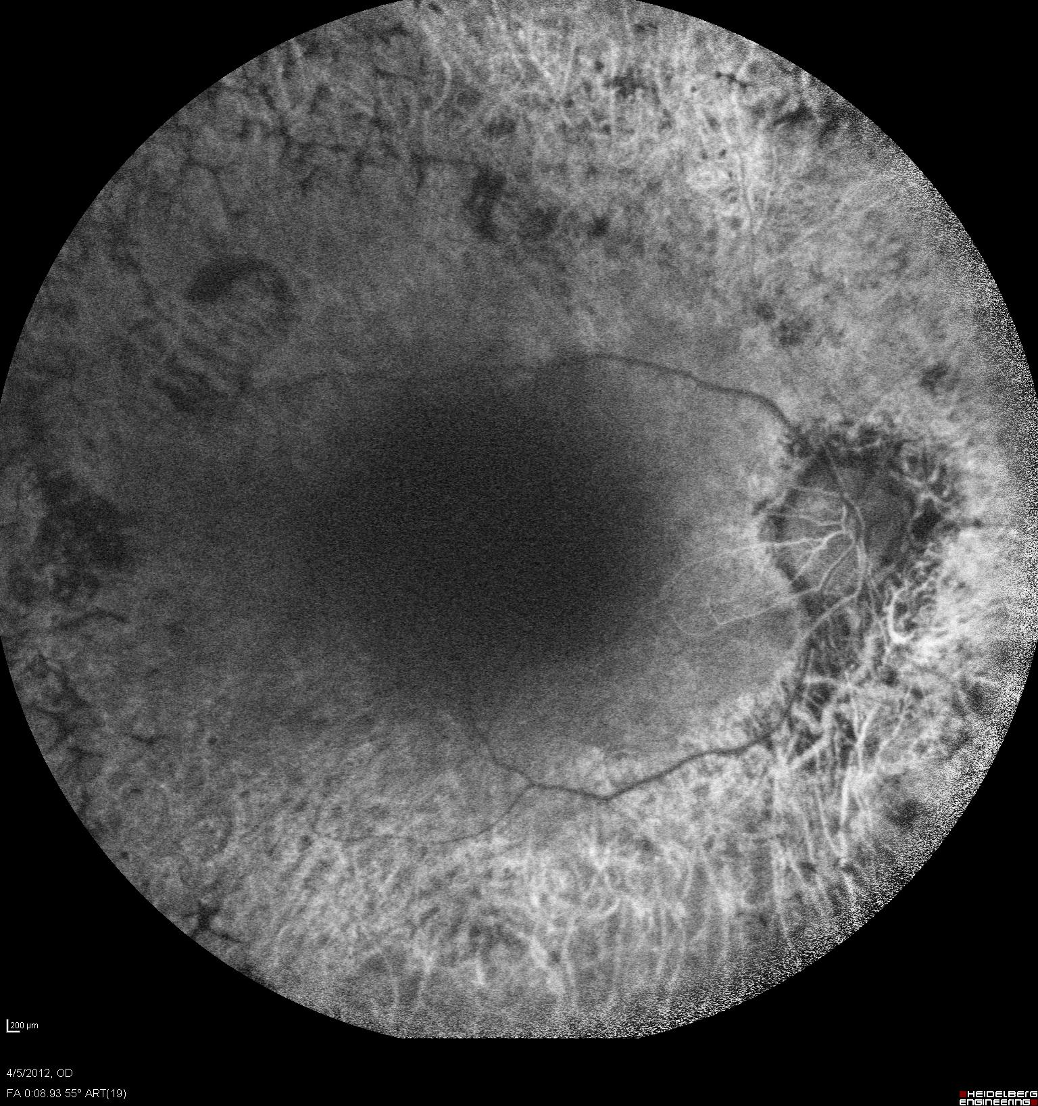

Figure 2. Fluorescein angiography of the left eye.
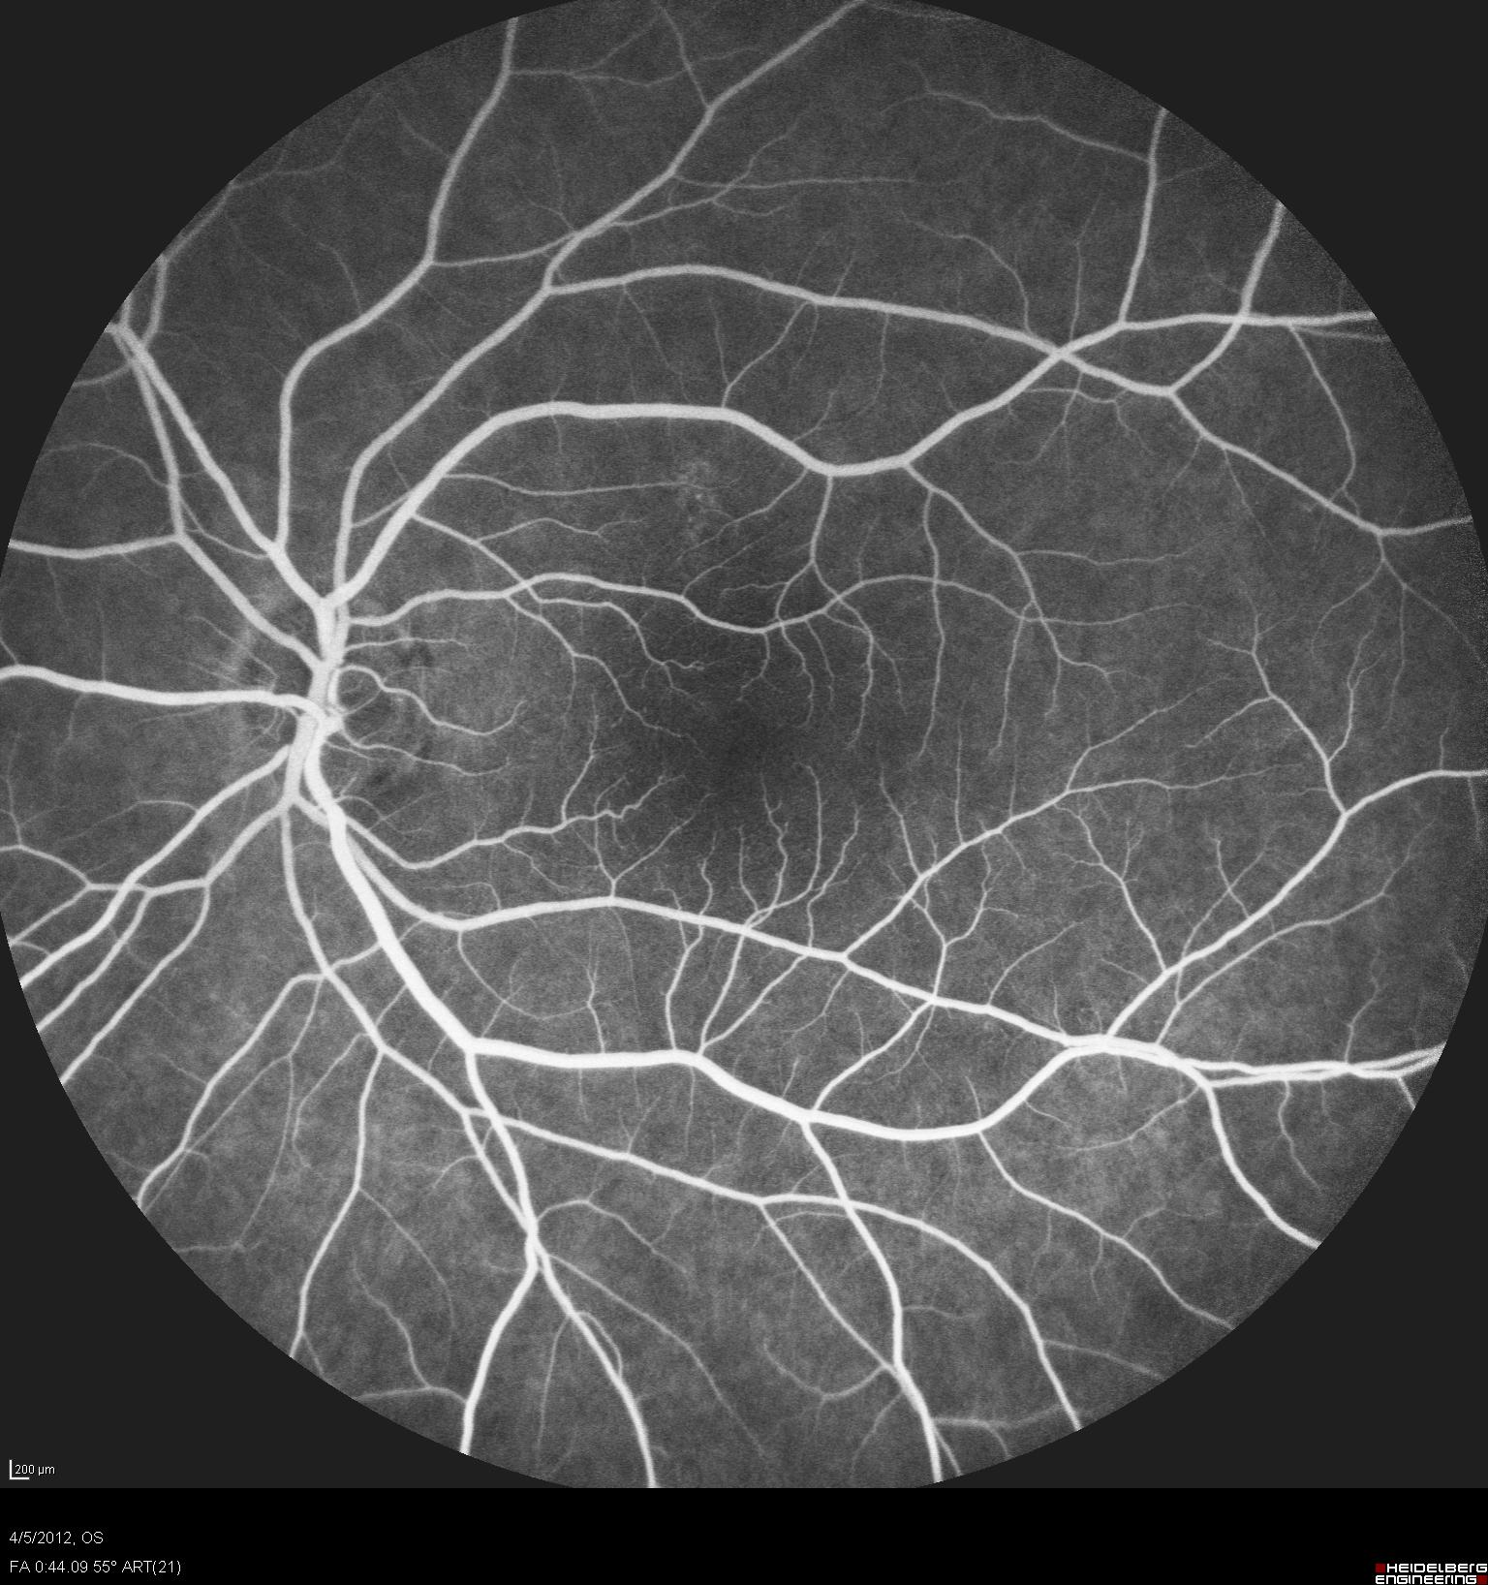

Figure 3. Computadorized visual Field RE and LE.

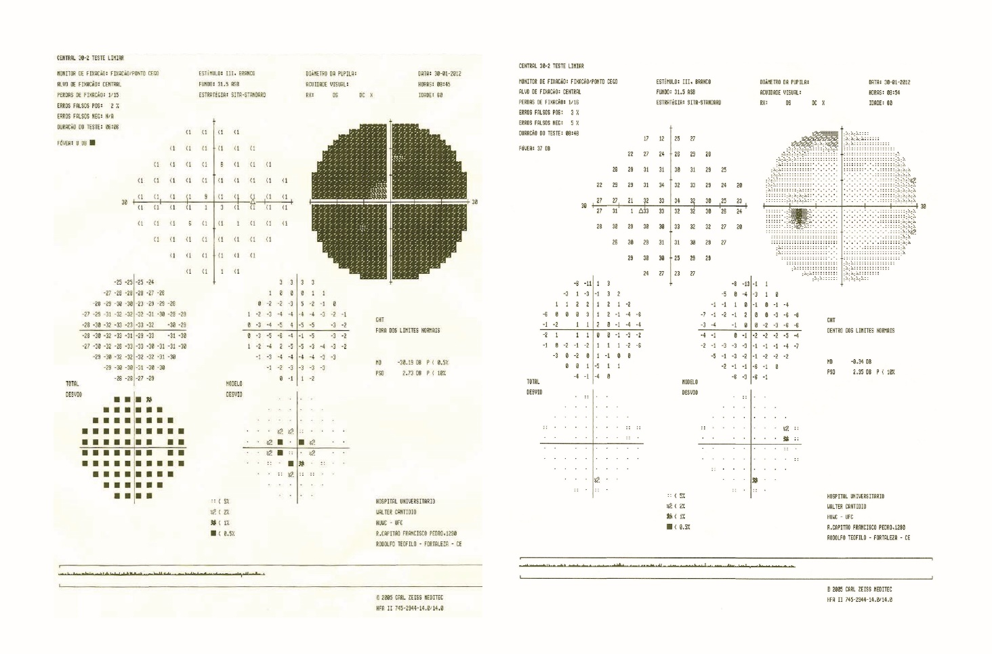

Figure 4. ERG RE and LE.

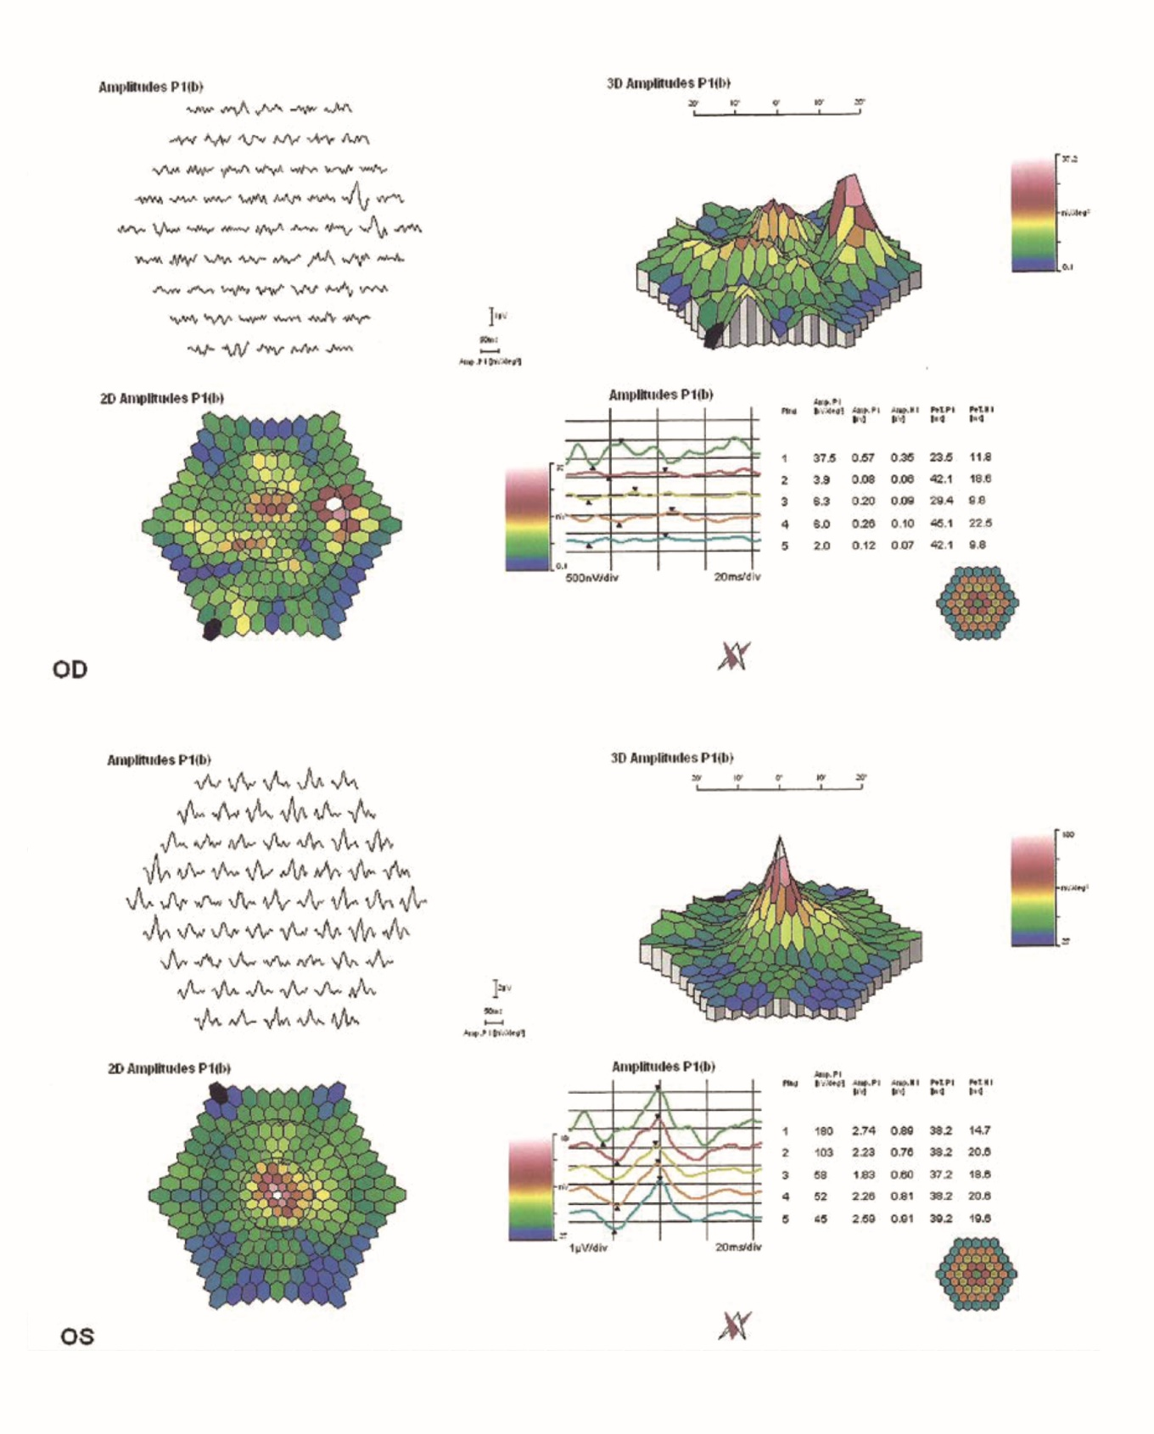

Figure 5. EOG RE and LE.

